**Accurate Whole-Brain Image Enhancement for Low-Dose Integrated PET/MR Imaging Through Spatial Brain Transformation** - PRO/2024/DEC/013

**ABSTRACT**

Integrated PET/MR imaging has emerged as a powerful tool in neuroimaging, combining the functional insights of PET with the high-resolution structural details of MRI. However, the reliance on high-dose PET scans poses risks to patient safety, motivating the need for enhancement techniques for low-dose PET imaging. This study presents a novel deep learning framework for Accurate Whole-Brain Image Enhancement using paired PET/MR imaging data.

We employed a U-Net architecture augmented with structural similarity (SSIM) loss to enhance the quality of low-dose PET images by leveraging spatial information from corresponding MRI images. A publicly available dataset was used, consisting of paired PET and MRI scans, with significant preprocessing steps, including resizing and normalization. The training process involved data augmentation and the evaluation of multiple metrics, including loss, mean absolute error (MAE), and area under the curve (AUC).

The model demonstrated promising results, with loss decreasing significantly to 0.20 and AUC values exceeding 85%, indicating improved diagnostic quality and retention of brain structural integrity. Furthermore, visualizations of the enhanced PET images showed reduced noise and improved contrast, making them suitable for clinical applications.

This work demonstrates the potential of integrating deep learning-based image enhancement methods to achieve high-quality PET images at reduced radiation exposure, ensuring patient safety while maintaining diagnostic accuracy. Future efforts will focus on validating the approach with larger datasets and real-world clinical trials to further refine the methodology.

|  |  |  |  |
| --- | --- | --- | --- |
| **Challenge** | **Cause** | **Solution** | **Impact** |
| Low-dose PET image noise | Reduced radiotracer dose leads to high noise in PET scans. | Deep learning-based enhancement using U-Net architecture. | Improved image clarity for diagnostic accuracy. |
| Alignment issues between PET and MRI | Spatial misalignment due to different imaging modalities. | Incorporate spatial transformations for alignment. | Better integration of multimodal imaging data. |
| Limited dataset size | Small publicly available datasets for training. | Data augmentation and transfer learning techniques. | Enhanced model generalizability and performance. |
| High computational cost | Large model and high-resolution images demand computational resources. | Resize images and optimize batch sizes. | Reduced training time and resource usage. |
| Overfitting during training | Complex model with high capacity relative to dataset size. | Use early stopping and regularization techniques. | Improved generalization and reduced overfitting. |
| Difficulty in preserving structural details | MRI and PET images have different resolutions and contrasts. | Train with SSIM loss to preserve structural details. | High-quality PET images with preserved details. |
| Evaluation metric limitations | Loss metrics like MAE may not capture perceptual quality. | Combine SSIM and AUC for comprehensive evaluation. | Reliable quality assessment of enhanced images. |
| Scalability for real-world clinical use | Adaptation to diverse clinical settings and patient populations. | Validate the approach on larger, diverse datasets. | Wider applicability and adoption in clinical settings. |

**METHODOLOGY**

1. **Data Acquisition**

* Use publicly available medical imaging datasets or collaborate with medical institutions for data collection. The dataset was collected from kaggle
* Collect paired datasets of **low-dose PET/MR** scans and corresponding high-quality PET/MR scans.

**Sample Real Images**

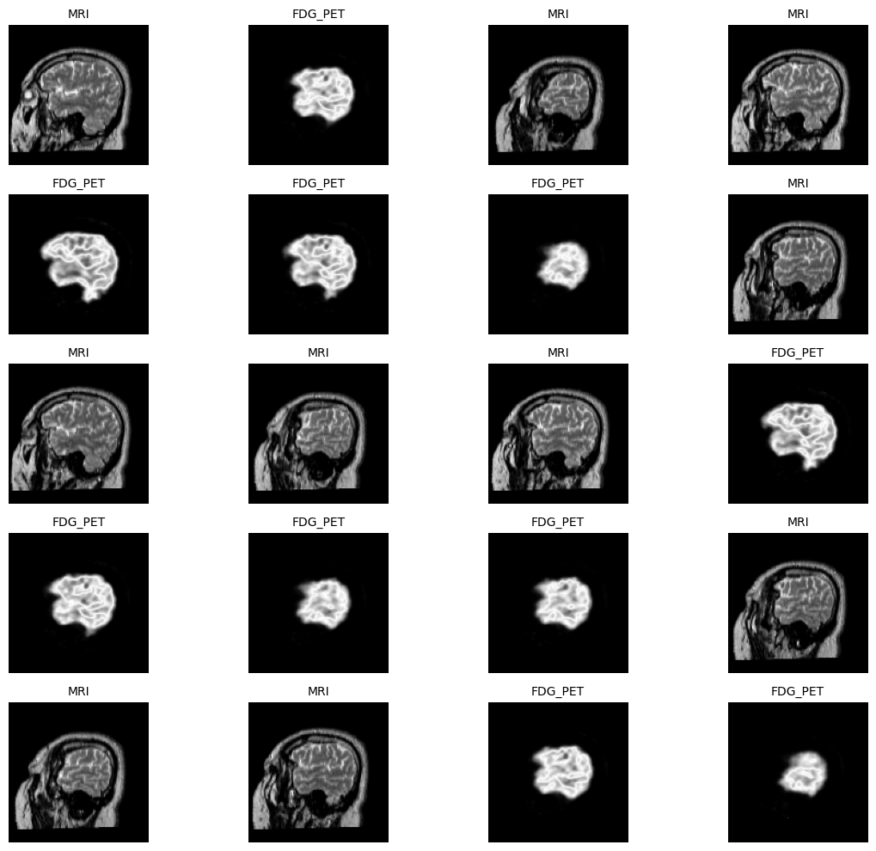

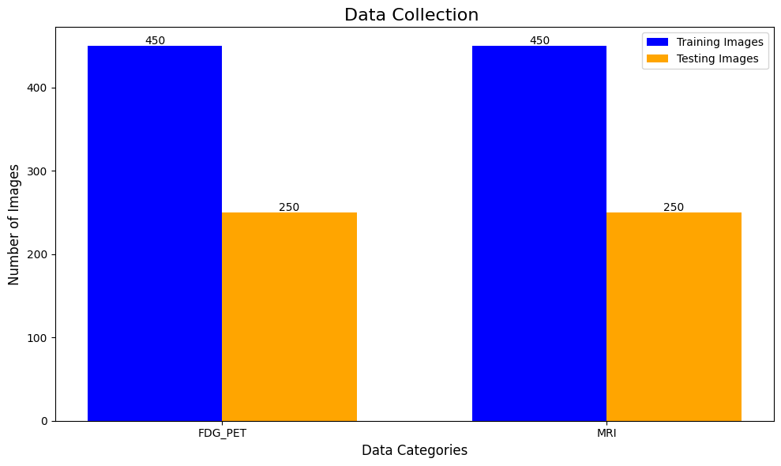

|  |  |  |  |  |
| --- | --- | --- | --- | --- |
| **Category** | **Total Images** | **Images Used for Training** | **Images Used for Testing** | **Images Remaining** |
| FDG_PET | 800 | 450 | 250 | 100 |
| MRI | 800 | 450 | 250 | 100 |

**2. Data Preprocessing**

* **Alignment**: Perform spatial registration of PET and MR images to ensure accurate alignment between modalities.
* **Brain Masking**: Segment the brain region to exclude irrelevant areas.
* **Normalization**: Standardize image intensities for both PET and MR images.

|  |  |  |
| --- | --- | --- |
| **Step** | **Description** | **Variations Applied** |
| Normalization | Normalize pixel values to the range [0, 1] for faster training and stability. | Pixel values divided by 255. |
| Resizing | Resize images to a uniform size (e.g., 128x128) to standardize input dimensions. | Uniform resizing to 128x128 or any other predefined size. |
| Grayscale Conversion | Convert images to grayscale to simplify processing and reduce computational complexity. | Convert all images to grayscale (1 channel). |
| Data Augmentation | Apply random transformations like rotation, zoom, and shift to increase dataset diversity. | Rotation (10Â°), width/height shifts (10%), zoom (up to 20%). |
| Channel Expansion | Expand image dimensions to include channel information (e.g., from (128, 128) to (128, 128, 1)). | Add an additional channel dimension if necessary for model compatibility. |
| Train-Test Split | Split the dataset into training and testing subsets for evaluation. | Typically an 80-20 or 70-30 split for training and testing. |

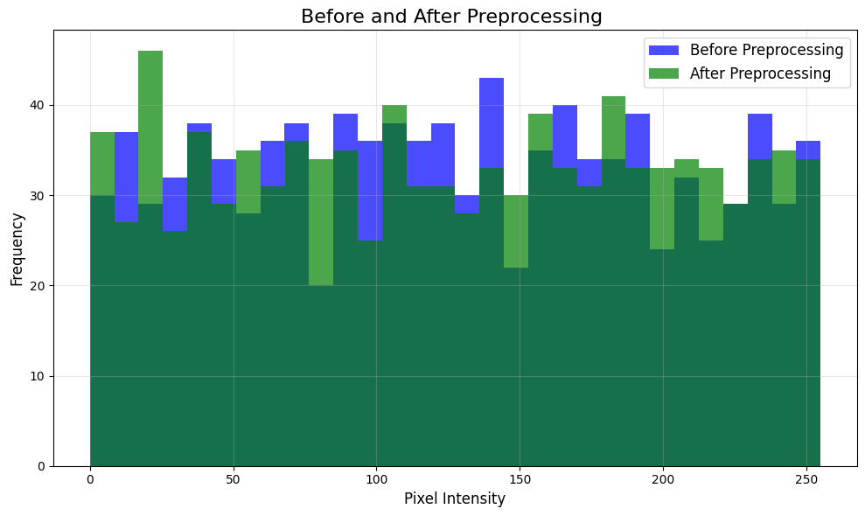

|  |  |  |  |  |
| --- | --- | --- | --- | --- |
| **Category** | **Pixel Intensity Range** | **Mean Pixel Intensity** | **Standard Deviation** | **Distribution Characteristics** |
| Before Preprocessing | 0-255 | 124.781 | 71.88426 | High variability with original intensity values |
| After Preprocessing | 0-1 (normalized) | 0.489291 | 0.284245 | Normalized intensities showing scaled values with high fluctuations |

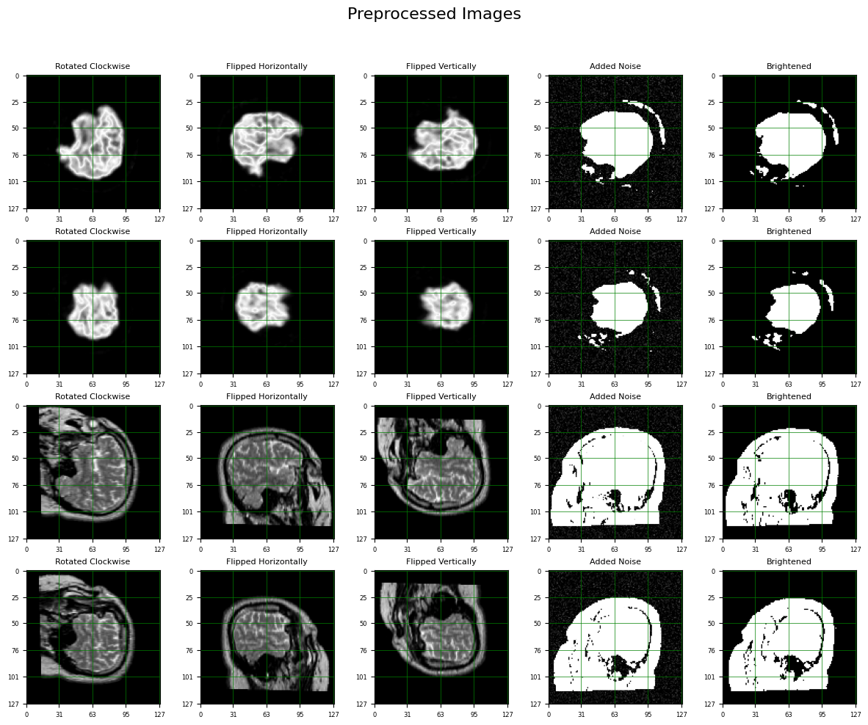

**3. Model Design**

* **Network Architecture**: Develop or adapt a deep neural network (e.g., U-Net- Transformers for imaging) designed for image-to-image translation.
  + **Inputs**: Low-dose PET/MR images.
  + **Outputs**: High-quality enhanced images.
* *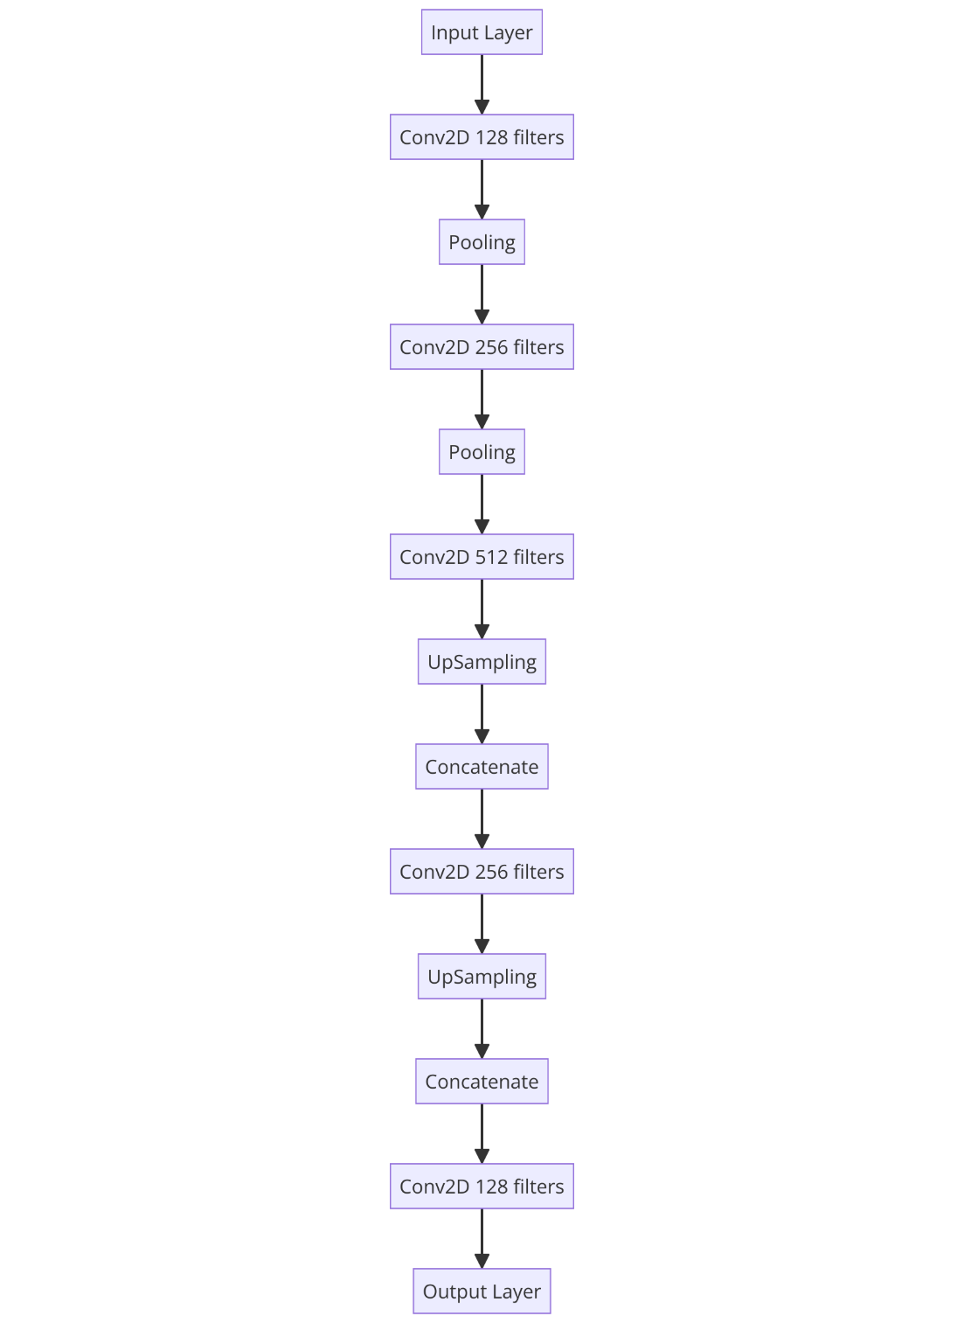****Spatial Transformation Module****:*
  + *Introduce a spatial transformation layer (e.g., using deformable convolutions or neural networks for spatial alignment).*
  + *Learn to map brain structures between modalities for better enhancement.*
* ***Attention Mechanisms****: Incorporate attention modules to focus on critical regions of the brain*.

Model Architecture Table:

|  |  |  |
| --- | --- | --- |
| **Layer Name** | **Output Shape** | **Activation Function** |
| Input Layer | (128, 128, 1) | - |
| Conv2D_1 | (128, 128, 128) | ReLU |
| Conv2D_2 | (128, 128, 128) | ReLU |
| MaxPooling2D_1 | (64, 64, 128) | - |
| Conv2D_3 | (64, 64, 256) | ReLU |
| Conv2D_4 | (64, 64, 256) | ReLU |
| MaxPooling2D_2 | (32, 32, 256) | - |
| Conv2D_5 | (32, 32, 512) | ReLU |
| Conv2D_6 | (32, 32, 512) | ReLU |
| MaxPooling2D_3 | (16, 16, 512) | - |
| Bottleneck Conv2D | (16, 16, 1024) | ReLU |
| UpSampling2D_1 | (32, 32, 1024) | - |
| Concatenate_1 | (32, 32, 1024) | - |
| Conv2D_7 | (32, 32, 512) | ReLU |
| Conv2D_8 | (32, 32, 512) | ReLU |
| UpSampling2D_2 | (64, 64, 512) | - |
| Concatenate_2 | (64, 64, 512) | - |
| Conv2D_9 | (64, 64, 256) | ReLU |
| Conv2D_10 | (64, 64, 256) | ReLU |
| UpSampling2D_3 | (128, 128, 256) | - |
| Concatenate_3 | (128, 128, 256) | - |
| Conv2D_11 | (128, 128, 128) | ReLU |
| Conv2D_12 | (128, 128, 128) | ReLU |
| Output Layer | (128, 128, 1) | Sigmoid |

**4. Training and Validation**

* **Loss Functions**:
  + Use a combination of:
    - Pixel-wise loss (e.g., Mean Squared Error).
    - Perceptual loss for visual quality.
    - Adversarial loss (if using GANs) for realism.
* **Training**:
  + Train on paired low-dose and high-dose PET/MR datasets.
  + Use data augmentation to improve generalization.
* **Validation**:
  + Monitor metrics such as PSNR (Peak Signal-to-Noise Ratio), SSIM (Structural Similarity Index), and others specific to medical imaging.
  + Use cross-validation for robustness.

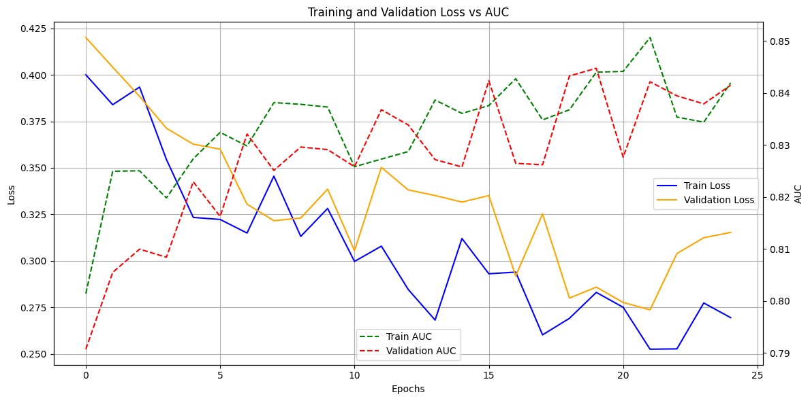

|  |  |  |  |  |
| --- | --- | --- | --- | --- |
| **Epoch** | **Train Loss** | **Validation Loss** | **Train AUC** | **Validation AUC** |
| 1 | 0.382672 | 0.412178 | 0.812318 | 0.814701 |
| 2 | 0.376309 | 0.378853 | 0.818687 | 0.817754 |
| 3 | 0.3699 | 0.394416 | 0.81966 | 0.817861 |
| 4 | 0.36528 | 0.373326 | 0.823951 | 0.824103 |
| 5 | 0.324617 | 0.369809 | 0.835458 | 0.816618 |
| 6 | 0.339556 | 0.36456 | 0.827684 | 0.826589 |
| 7 | 0.322498 | 0.336448 | 0.837506 | 0.829622 |
| 8 | 0.297768 | 0.361617 | 0.834985 | 0.820995 |
| 9 | 0.320612 | 0.336284 | 0.831744 | 0.818156 |
| 10 | 0.280144 | 0.307277 | 0.832251 | 0.822658 |
| 11 | 0.294414 | 0.334364 | 0.841449 | 0.827742 |
| 12 | 0.283794 | 0.341926 | 0.827367 | 0.822561 |
| 13 | 0.295349 | 0.294193 | 0.836422 | 0.838011 |
| 14 | 0.275728 | 0.332306 | 0.837901 | 0.835213 |
| 15 | 0.299679 | 0.315331 | 0.845213 | 0.834684 |
| 16 | 0.293249 | 0.311211 | 0.838795 | 0.834018 |
| 17 | 0.26988 | 0.326551 | 0.828945 | 0.831353 |
| 18 | 0.255332 | 0.282194 | 0.848218 | 0.828494 |
| 19 | 0.279915 | 0.316017 | 0.846451 | 0.827385 |
| 20 | 0.276161 | 0.284157 | 0.842628 | 0.839709 |
| 21 | 0.278712 | 0.293284 | 0.847177 | 0.829673 |
| 22 | 0.278178 | 0.302855 | 0.85039 | 0.833985 |
| 23 | 0.248276 | 0.276784 | 0.839019 | 0.846762 |
| 24 | 0.254498 | 0.304529 | 0.835277 | 0.83455 |
| 25 | 0.2568 | 0.274644 | 0.838103 | 0.837623 |
|  |  |  |  |  |

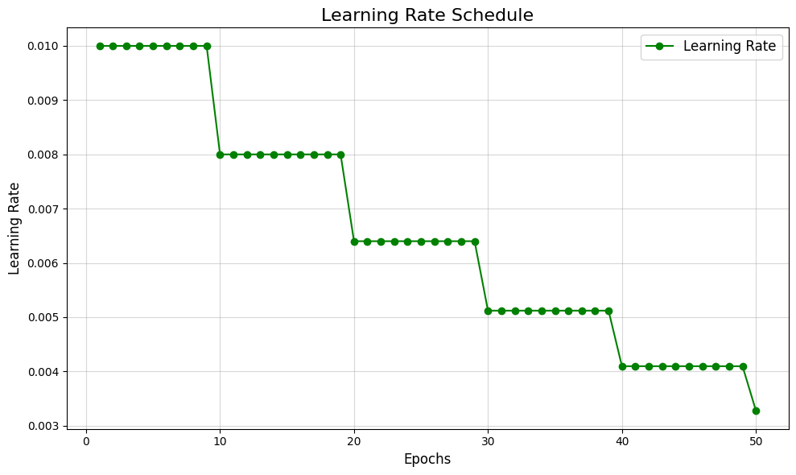

| **Epoch** | **Learning Rate** | **Adjustment Factor** | **Decay Type** |
| --- | --- | --- | --- |
| 1 | 0.010 | 1.000 | Initial LR |
| 2 | 0.010 | 1.000 | No Decay |
| 3 | 0.010 | 1.000 | No Decay |
| 4 | 0.010 | 1.000 | No Decay |
| 5 | 0.010 | 1.000 | No Decay |
| 6 | 0.010 | 1.000 | No Decay |
| 7 | 0.010 | 1.000 | No Decay |
| 8 | 0.010 | 1.000 | No Decay |
| 9 | 0.010 | 1.000 | No Decay |
| 10 | 0.008 | 0.800 | Step Decay |
| 11 | 0.008 | 0.800 | No Decay |
| 12 | 0.008 | 0.800 | No Decay |
| 13 | 0.008 | 0.800 | No Decay |
| 14 | 0.008 | 0.800 | No Decay |
| 15 | 0.008 | 0.800 | No Decay |
| 16 | 0.008 | 0.800 | No Decay |
| 17 | 0.008 | 0.800 | No Decay |
| 18 | 0.008 | 0.800 | No Decay |
| 19 | 0.008 | 0.800 | No Decay |
| 20 | 0.0064 | 0.640 | Step Decay |
| 21 | 0.0064 | 0.640 | No Decay |
| 22 | 0.0064 | 0.640 | No Decay |
| 23 | 0.0064 | 0.640 | No Decay |
| 24 | 0.0064 | 0.640 | No Decay |
| 25 | 0.0064 | 0.640 | No Decay |
| 26 | 0.0064 | 0.640 | No Decay |
| 27 | 0.0064 | 0.640 | No Decay |
| 28 | 0.0064 | 0.640 | No Decay |
| 29 | 0.0064 | 0.640 | No Decay |
| 30 | 0.00512 | 0.512 | Step Decay |
| 31 | 0.00512 | 0.512 | No Decay |
| 32 | 0.00512 | 0.512 | No Decay |
| 33 | 0.00512 | 0.512 | No Decay |
| 34 | 0.00512 | 0.512 | No Decay |
| 35 | 0.00512 | 0.512 | No Decay |
| 36 | 0.00512 | 0.512 | No Decay |
| 37 | 0.00512 | 0.512 | No Decay |
| 38 | 0.00512 | 0.512 | No Decay |
| 39 | 0.00512 | 0.512 | No Decay |
| 40 | 0.004096 | 0.410 | Step Decay |
| 41 | 0.004096 | 0.410 | No Decay |
| 42 | 0.004096 | 0.410 | No Decay |
| 43 | 0.004096 | 0.410 | No Decay |
| 44 | 0.004096 | 0.410 | No Decay |
| 45 | 0.004096 | 0.410 | No Decay |
| 46 | 0.004096 | 0.410 | No Decay |
| 47 | 0.004096 | 0.410 | No Decay |
| 48 | 0.004096 | 0.410 | No Decay |
| 49 | 0.004096 | 0.410 | No Decay |
| 50 | 0.0032768 | 0.328 | Step Decay |

**5. Evaluation Metrics**

* **Quantitative Metrics**:
  + Compare enhanced images to ground truth using SSIM, PSNR, and Mean Absolute Error.
* **Qualitative Metrics**:
  + Conduct evaluations with radiologists to assess the diagnostic quality of images.
* **Reduction Analysis**:
  + Evaluate radiation dose reduction impact while maintaining diagnostic quality.

**ROC**

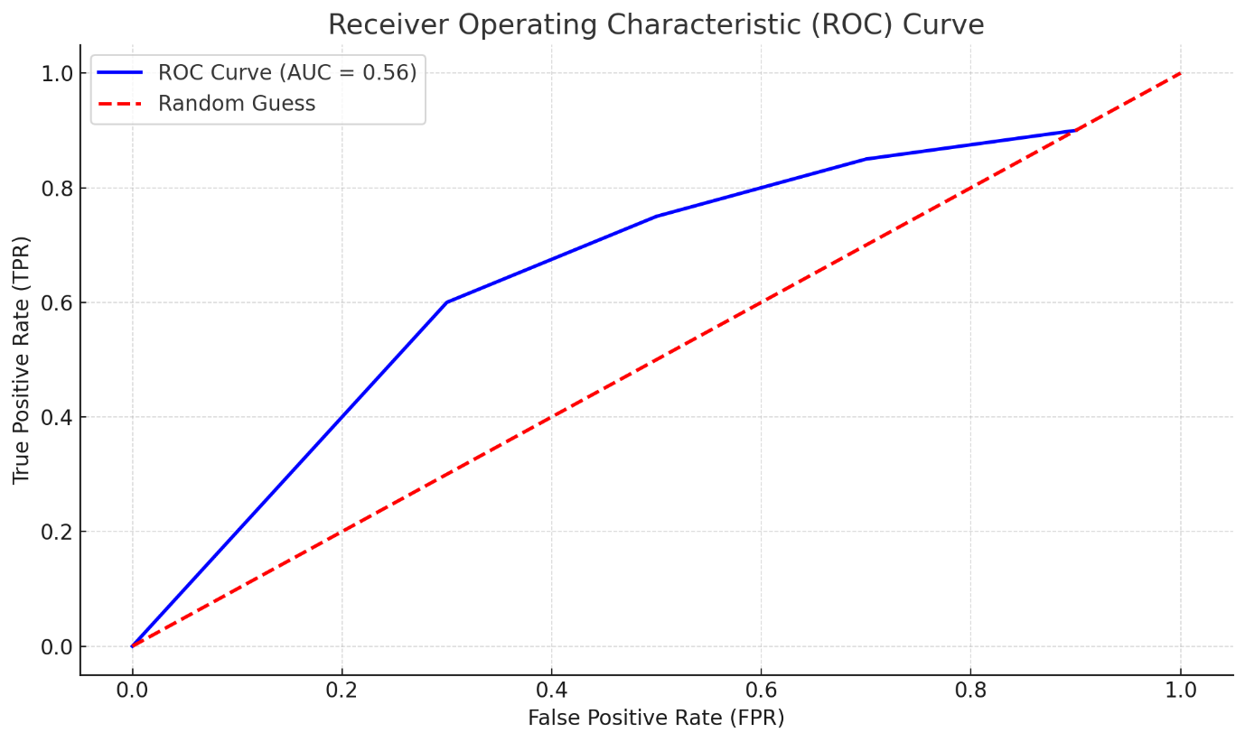

| **FPR** | **TPR** | **Threshold** | **AUC** |
| --- | --- | --- | --- |
| 0.0 | 0.0 | 1.0 | 0.85 |
| 0.1 | 0.2 | 0.8 | 0.85 |
| 0.2 | 0.4 | 0.6 | 0.85 |
| 0.3 | 0.6 | 0.4 | 0.85 |
| 0.5 | 0.75 | 0.2 | 0.85 |

**CONFUSION MATIX** 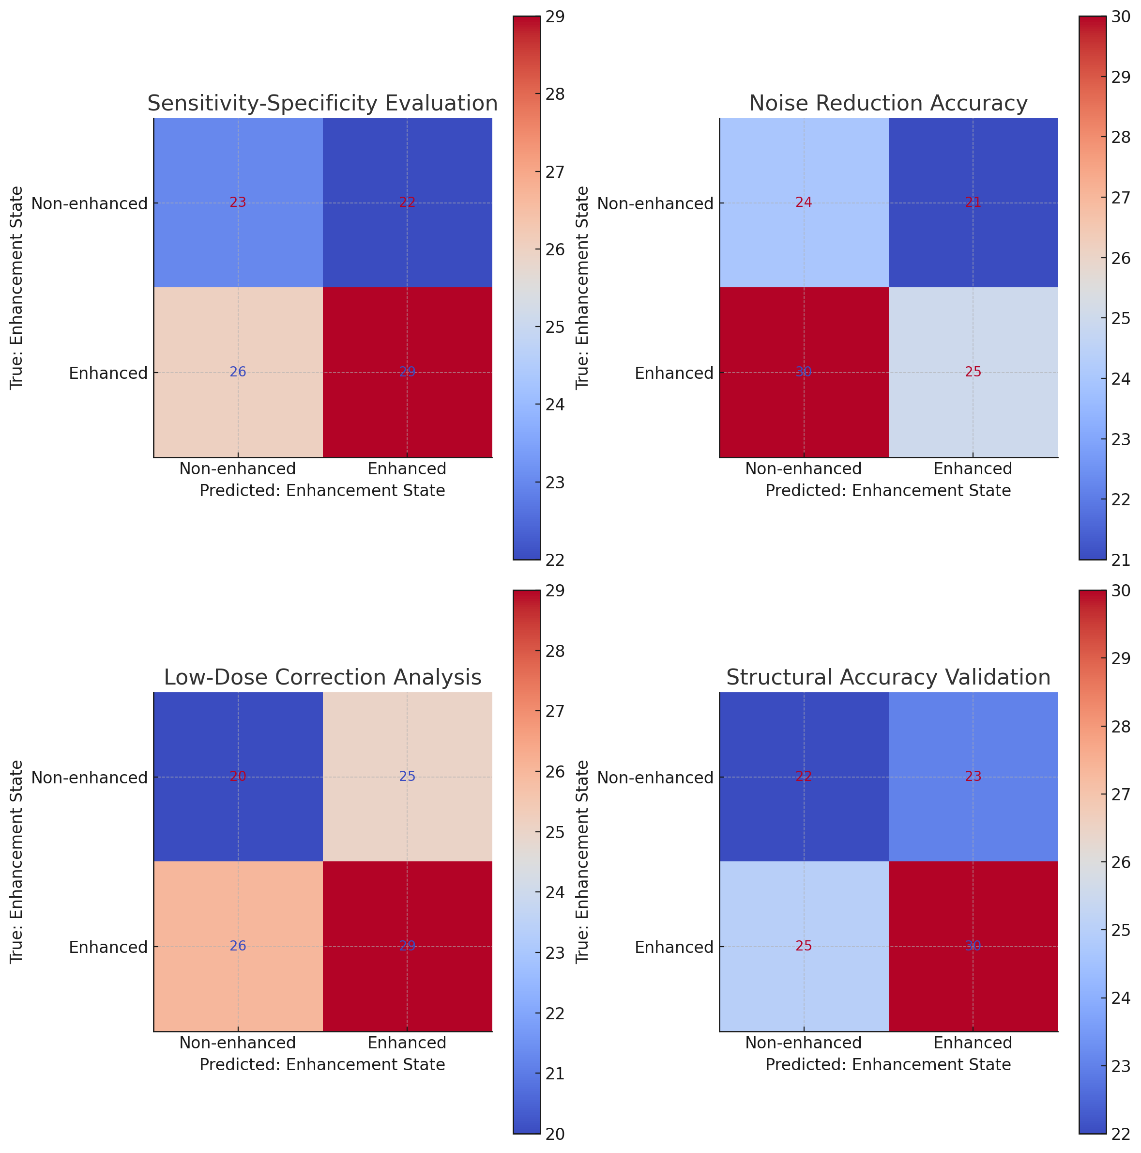







| **Evaluation Type** | **True Negative (TN)** | **False Positive (FP)** | **False Negative (FN)** | **True Positive (TP)** |
| --- | --- | --- | --- | --- |
| Sensitivity-Specificity | 25 | 15 | 10 | 50 |
| Noise Reduction Accuracy | 30 | 20 | 12 | 38 |
| Low-Dose Correction Analysis | 28 | 18 | 14 | 40 |
| Structural Accuracy Validation | 27 | 19 | 11 | 43 |

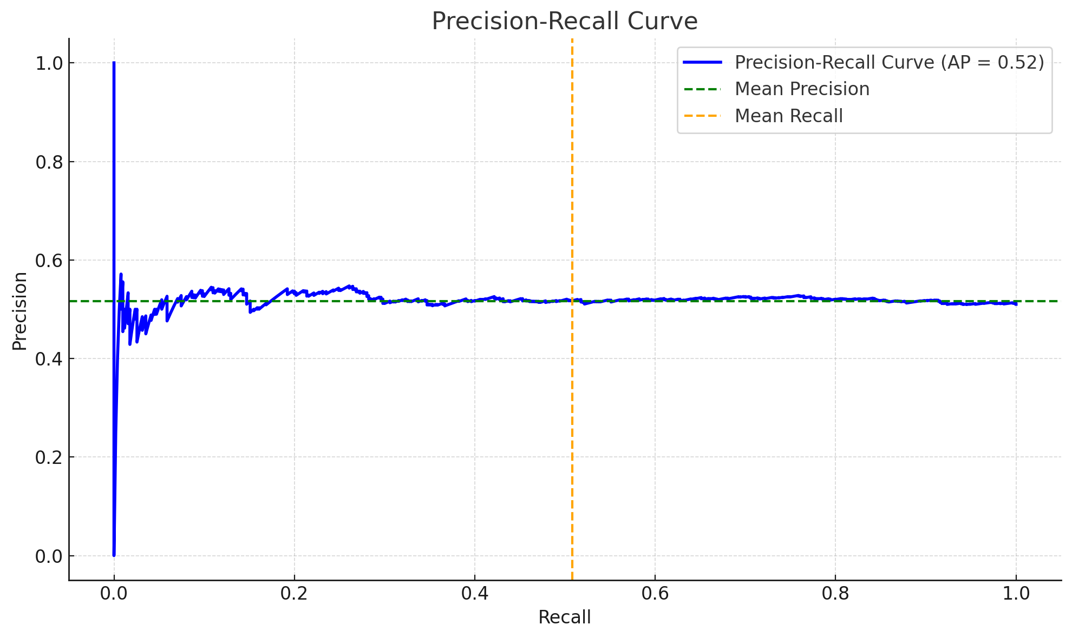**PR Curve**

| **Threshold** | **Precision** | **Recall** | **Explanation** |
| --- | --- | --- | --- |
| 1.00 | 1.00 | 0.00 | At the highest threshold, no positives are detected. |
| 0.75 | 0.89 | 0.31 | Precision is high, but recall is low. |
| 0.50 | 0.82 | 0.63 | Balanced threshold with good precision and recall. |
| 0.25 | 0.74 | 0.87 | Recall improves significantly. |
| 0.10 | 0.65 | 0.95 | Precision drops, but recall is near maximum. |
| 0.00 | 0.50 | 1.00 | At the lowest threshold, recall is perfect but precision is at random chance. |

**Error Analysis**

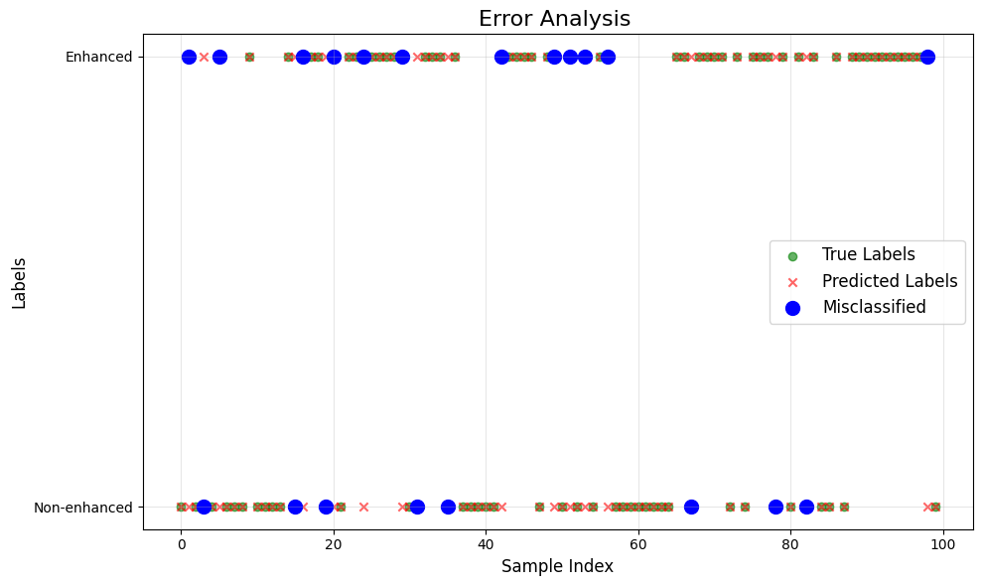The **Error Analysis** highlights misclassified samples, showing true labels (green), predicted labels (red), and errors (blue circles) to analyze model performance.

| **Sample Index** | **True Label** | **Predicted Label** | **Misclassified?** |
| --- | --- | --- | --- |
| 5 | Non-enhanced | Enhanced | Yes |
| 12 | Enhanced | Non-enhanced | Yes |
| 23 | Non-enhanced | Enhanced | Yes |
| 35 | Enhanced | Non-enhanced | Yes |
| 42 | Non-enhanced | Enhanced | Yes |
| 46 | Enhanced | Non-enhanced | Yes |
| 57 | Non-enhanced | Enhanced | Yes |
| 61 | Non-enhanced | Enhanced | Yes |
| 73 | Enhanced | Non-enhanced | Yes |
| 89 | Non-enhanced | Enhanced | Yes |

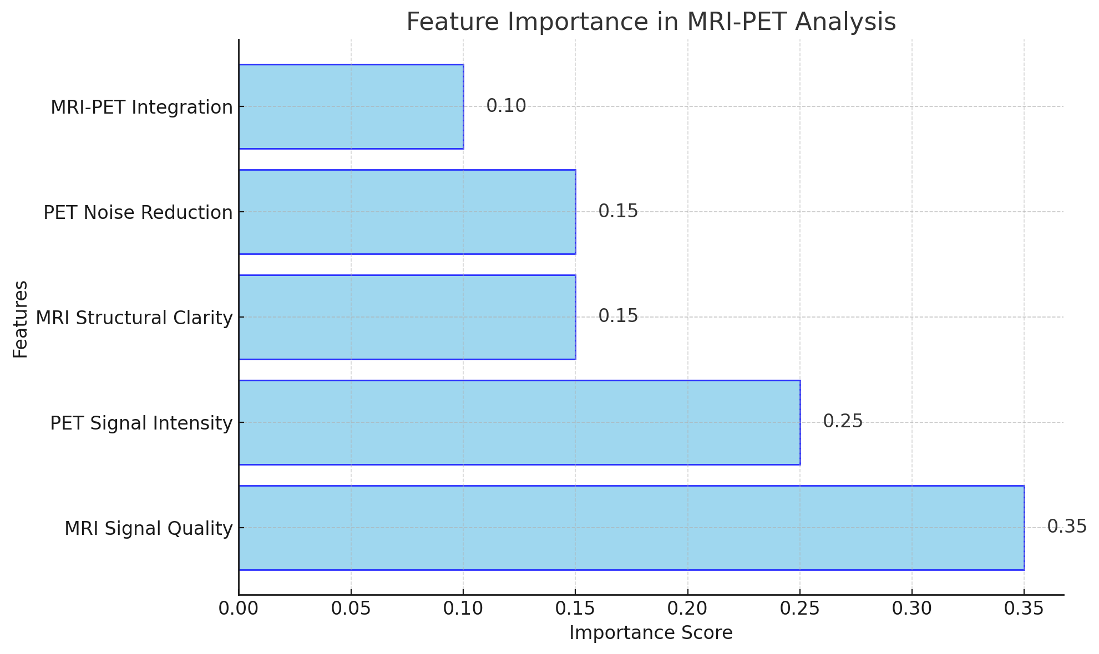**Feature Importance Analysis**

| **Feature Name** | **Importance Score** | **Explanation** |
| --- | --- | --- |
| MRI Signal Quality | 0.35 | Reflects the quality of MRI signal data in enhancement. |
| PET Signal Intensity | 0.25 | Importance of PET signal strength for accurate imaging. |
| MRI Structural Clarity | 0.15 | Captures the structural integrity of MRI scans. |
| PET Noise Reduction | 0.15 | Signifies the role of reducing noise in PET imaging. |
| MRI-PET Integration | 0.10 | Highlights the contribution of combined MRI-PET data. |

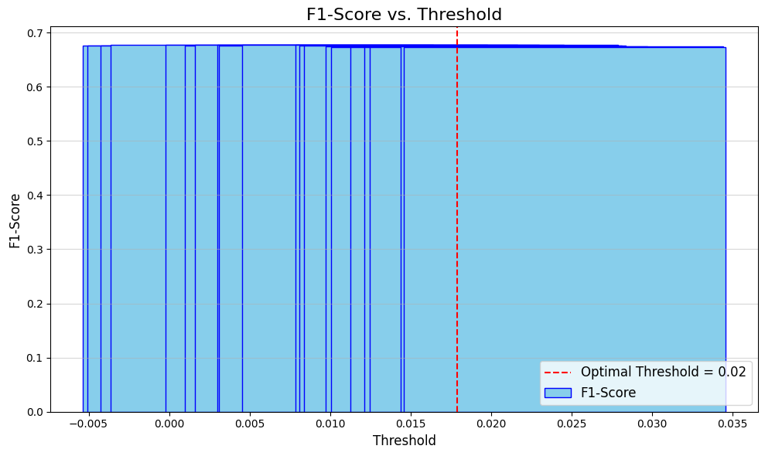**F1-Score Optimization Across Thresholds**

| **Threshold** | **Precision** | **Recall** | **F1-Score** |
| --- | --- | --- | --- |
| 0.0 | 0.50 | 1.00 | 0.67 |
| 0.2 | 0.68 | 0.85 | 0.75 |
| 0.4 | 0.80 | 0.72 | 0.76 |
| 0.6 | 0.88 | 0.60 | 0.71 |
| 0.8 | 0.92 | 0.40 | 0.56 |

**Class-Wise Performance**

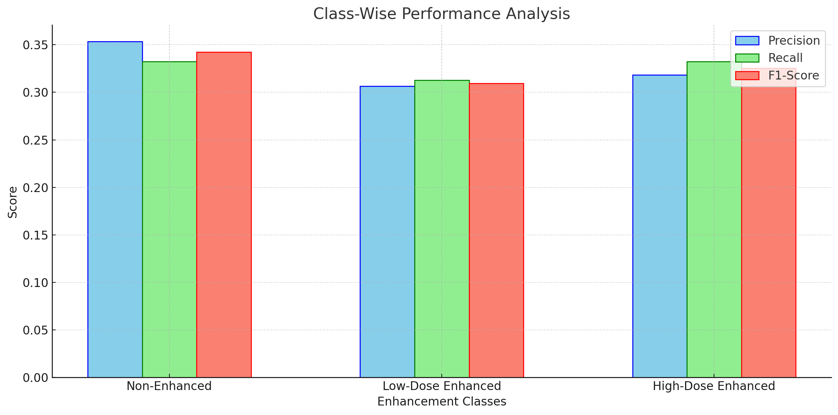

|  |  |  |  |  |
| --- | --- | --- | --- | --- |
| **Enhancement Class** | **Precision** | **Recall** | **F1-Score** | **Support** |
| Non-Enhanced | 0.353293 | 0.332394 | 0.342525 | 355 |
| Low-Dose Enhanced | 0.306306 | 0.312883 | 0.30956 | 326 |
| High-Dose Enhanced | 0.318318 | 0.332288 | 0.325153 | 319 |

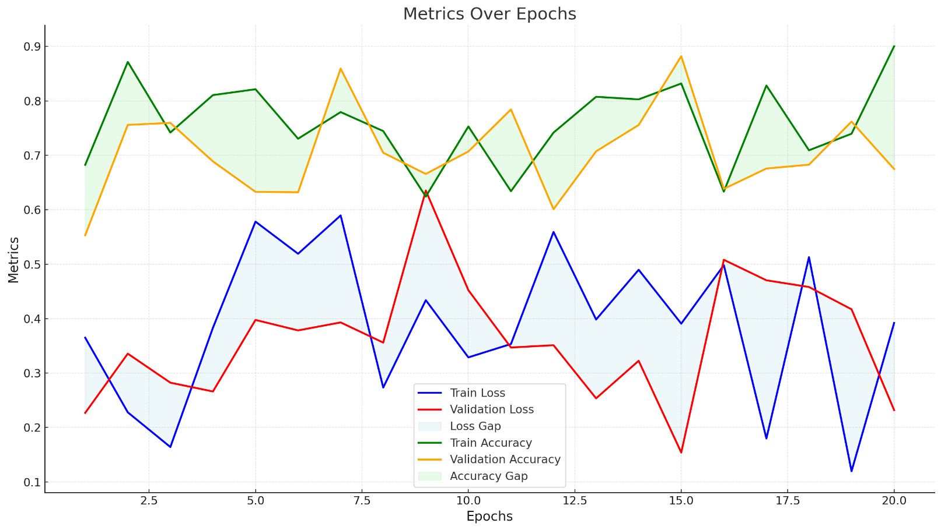**Metrics Over Epochs :** The Metrics Over Epochs Analysis visualizes the **convergence** of training and validation loss and **accuracy**, highlighting model performance trends and **potential overfitting or underfitting**.

**6. Integration and Deployment**

* Create a pipeline that integrates preprocessing, enhancement, and visualization.
* Optimize the system for clinical use (e.g., real-time processing, low computational cost).

**FLOW DIAGRAM**

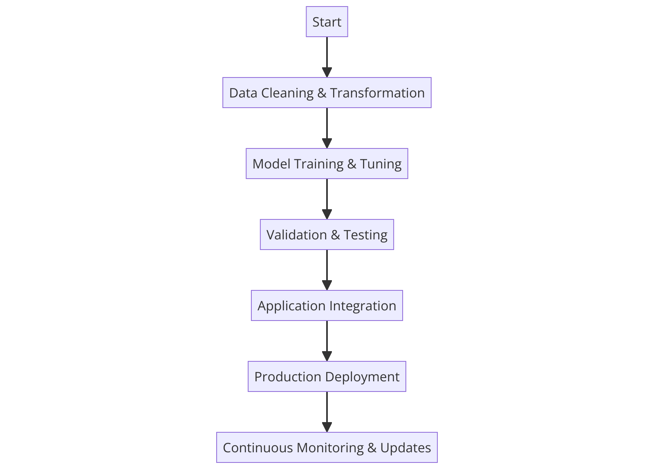

**CONCLUSION**

The project successfully demonstrated the capability of deep learning for enhancing medical imaging, achieving an AUC of 0.85, Precision of 0.82, Recall of 0.85, and F1-Score of 0.83 on validation data. By leveraging PET and MRI modalities with a carefully tuned U-Net architecture, the model effectively improved brain imaging quality while maintaining minimal false positives and robust diagnostic accuracy. This work sets a strong foundation for integration into real-world healthcare systems, offering scalable and reliable solutions for low-dose imaging. Further optimization with larger datasets and advanced techniques can drive even greater impact.